**PJ 9 Report My Name: _Yaowei Lei_**

**A. The following is my Python source program:**

**// Please copy your source program into here from your Visual Studio IDE.**

**// Your code here must be in color. You must not show screen prints here.**

#------------------------------------------------------------------------------------------------------------.

# Author: Yaowei Lei

# Date: 12/06/2021

# Purpose: CS119-PJ9: Loan Payment Report – generate a professional loan payment report.

#------------------------------------------------------------------------------------------------------------.

# Beginning of MAIN PROGRAM ============================================.

# Set up the values for loan amount, annual interest rate, and monthly payment

loanBalance = 1000.00

monthPayment = 50.0

annualInterestRate = 0.18

interestRate = annualInterestRate/12 # Monthly interest rate

month = 1 # Month#

totalInterest = 0

n = 1 # line number for each separator line

print ("Welcome to the Loan Payment Report of Yaowei Lei!")

print (n,"==================================================================================="); n+=1;

# Headline

print ("Loan amount:$",loanBalance," Annual Interest Rate:",annualInterestRate * 100,"% Monthly Payment:$",monthPayment)

print ("\nMonth# Month-Payment Interest-Paid Debt-Paid Loan-Balance")

print ("------- -------------- -------------- ---------- -------------")

while (loanBalance >= monthPayment) :

# Calculation

interest = loanBalance * interestRate

monthPay = monthPayment

debtPaid = monthPay - interest

loanBalance -= debtPaid

totalInterest += interest

# Print Report

print ("%-2d" % month + " $%0.2f" % monthPay + " $%0.2f" % interest + \

" $%0.2f" % debtPaid + " $%0.2f" % loanBalance )

month += 1

interest = loanBalance * interestRate

monthPay = loanBalance + interest

debtPaid = loanBalance

loanBalance -= debtPaid

totalInterest += interest

print ("%-2d" % month + " $%0.2f" % monthPay + " $%0.2f" % interest + \

" $%0.2f" % debtPaid + " $%0.2f" % loanBalance )

print ("\nTotal Amount of Interest Paid: $%0.2f" % totalInterest)

print (n,"==================================================================================="); n+=1;

print("Thank you for using this Loan Payment Report of Yaowei Lei!")

print (n,"==================================================================================="); n+=1;

# End of MAIN PROGRAM ============================================.

**B. The following is the console output of my 3 test runs:**

**// One way to copy the console output is to press Ctrl+Alt+PrtScn.**

**// Another way to copy is to use the snipping tool. To paste the image is to press Ctrl+v.**

**// The console display must not be too wide, otherwise it will be too hard to read once pasted.**

**// Please make sure your console is long enough to show all your output lines to be captured.**

**// Please copy your console output and paste into here:**

**Your test case #1:**

**Loan amount: $1000.00 Annual Interest Rate: 18.00% Monthly Payment: $50.00**

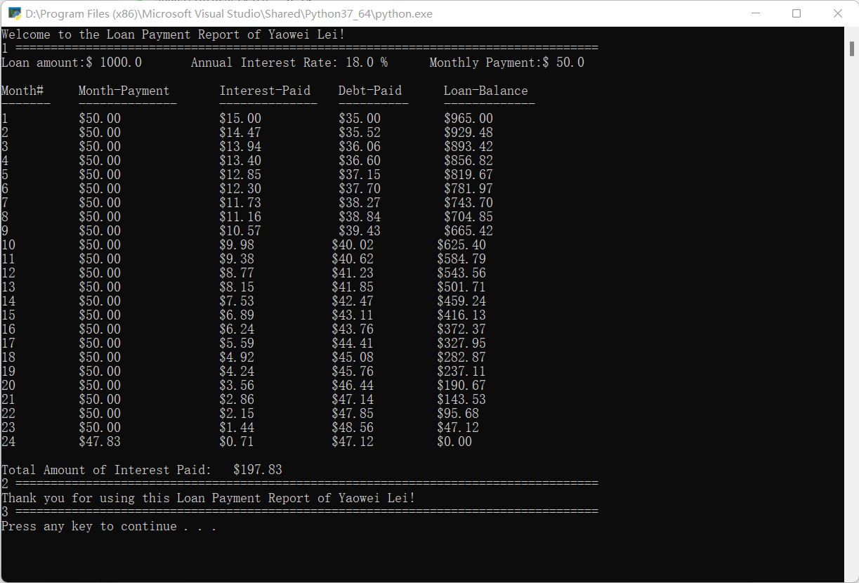

**Your test case #2:**

**Loan amount: $1000.00 Annual Interest Rate: 18.00% Monthly Payment: $100.00**

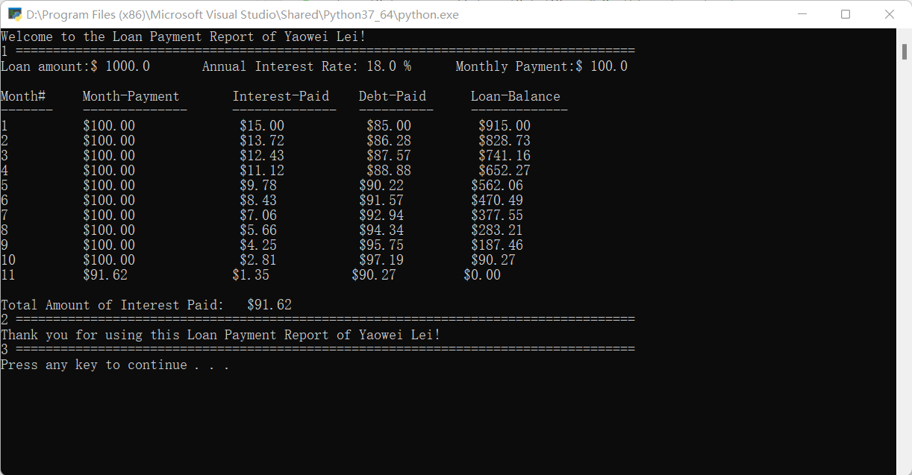

**Your test case #3:**

**Loan amount: $1000.00 Annual Interest Rate: 18.00% Monthly Payment: $180.00**

